Dakar Experience 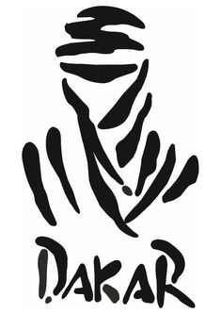
This is an exclusive access that is only available for those who are associated with a Dakar rider.
You get one week of following the Dakar rally and one week after the race in Dubai.
Flying in on rest day, following the Dakar rally for its second week in true Dakar style…in tents ⛺, with full access to the bivouac, eating areas, shower and toilet facilities and the ability to mix with the top riders and drivers of the world rally scene! During the day you travel at your leisure to viewing points or can just push through to the next bivouac, it’s almost like you’re in the race itself! Travelling with a group of likeminded rally lovers seeing the crazy lands of Saudi Arabia you will have no choice but to have fun on this adventure.
Once the race is complete, we all meet back in Dubai for a mingle and debrief 🍻.
The fun doesn’t stop there with the choice of many different adventures Dubai has to offer, from sipping beers in a pub to riding camels in the desert this package has it all.
This is an all-inclusive package minus meals and drinks during the second week.
Price to be confirmed available soon
Viewing of itinerary available soon
This will be a trip of a lifetime and cannot be bought by outsiders.

